Winson Wireless Bluetooth Barcode Scanner User Manual V1.1

Revision Date：2019-8-26

Revision Record :2019/07/12
1.Changed the manual to the manual of the Wireless Bluetooth Barcode Scanner
2.This manual is applicable to the WINSON Bluetooth, with firmware Src-0116 V1.6 and firmware Src-0121 V1.1.

Application Range:
Firmware | Note
Src-0116 V1.6 | V1.6 and above
Src-0121 V1.1 | V1.6 and above

Comprehensive settings
1. Set the barcode to print by using the CODE B of Code 128.
2. The asterisk (*) in the description part indicates the factory default parameters.
3.Set the instruction data format.

Table 3.3-1 Setting instruction data format
Prefix | Setting Object | Type | Parameter
WN- | T-/R-/W- | Refer to “Setup Barcode Type Table” | *****
Note:This format does not include instructions for entering settings and saving and exiting settings.

Table 3.3-2 Setup instruction data format analysis
Format | Data | Description
Prefix | @.WN- | Fixed prefix characters
Setting Object | T-/R-/W- | T-:Means the setup barcode is directly to the sender  R-:It means that the setting barcode is directly to the receiving end,and the setting barcode of the receiving end needs to be forwarded by the transmitting end through wireless transmission.  W-:The sender and receiver work together
Type |  | Pls refer to the “Setup Barcode Type Table”
Parameter |  | Parameter is 4 characters in the range of “0~9”

3.4 Setup Barcode Type Table
Table 3.4-1 Setup Type Table
Type | Description
A | Wireless pairing / disconnection operation
B | Multi-language Settings
C | View Firmware informations/Change frequency
D | Reserve
F | Realtime Mode/Inventory Mode/Data manipulation under Inventory Mode
G | Sleep Time
H | Restore Factory Default
I | Data Transmission Form、Start/Terminator Mode Setting、Customize Start/Terminator
K | Firmware Upgrade Command of Sender end & Receiving End
L | USB wired output switch

- Barcode Instruction Setting
  - Bluetooth Connection Operation Instruction
Funtion | Note
Disconnect from the receiver | When the scanner is to be connected to a mobile device (mobile phone / tablet), it needs to be disconnected from the receiver by scanning the barcode (if there is no receiver, this operation is not required). If you need to connect the receiver back, first set the Bluetooth communication mode to BLE, and then restart the receiver (You can short press the boton to open the connection function ).
Unpair from phone | After pairing with a mobile device (phone / tablet), you can scan the barcode to unpair (only Android models connected in HID mode).

Disconnect from the receiver | 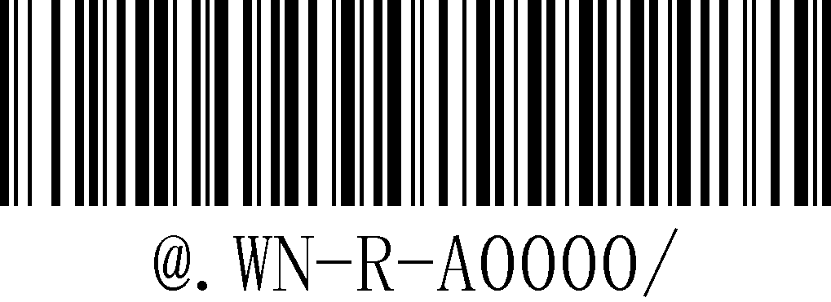
Unpair from phone | 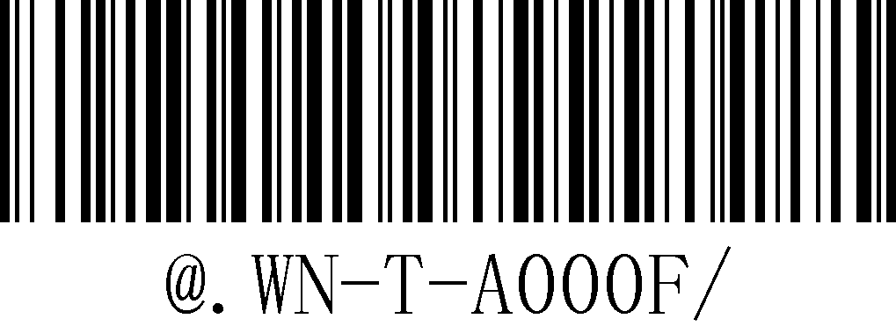

  - Bluetooth Communication Mode Setting

Bluetooth HID Mode | 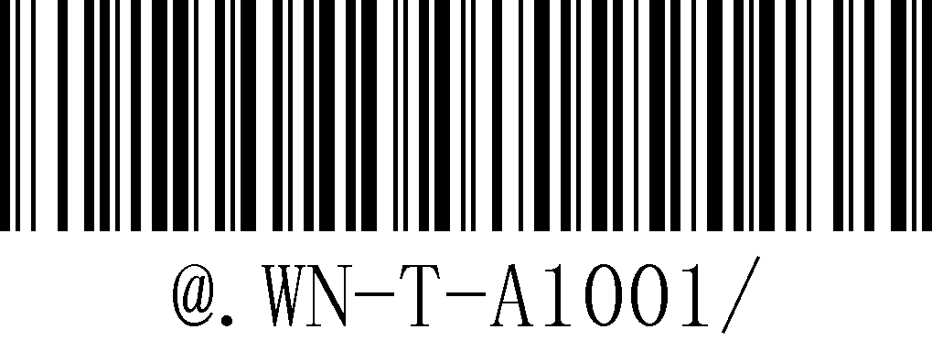
Bluetooth SPP Mode | 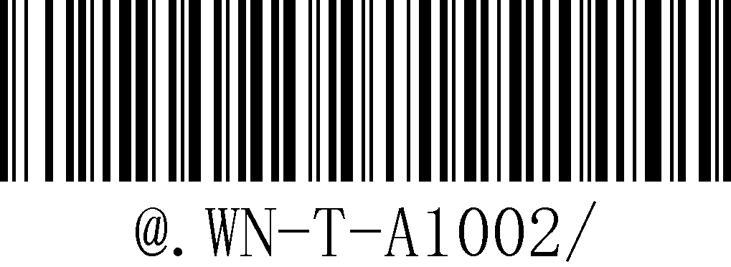
Bluetooth BLE Mode | 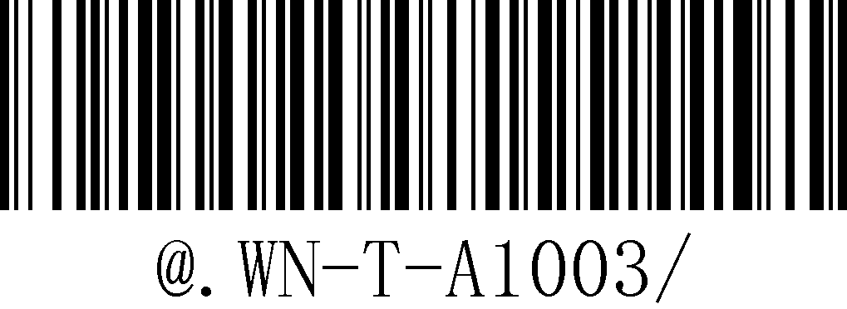

Note★:Pls make sure the barcode scanner were disconnention when switing modes.

  - Multi-Language Setting
USA | 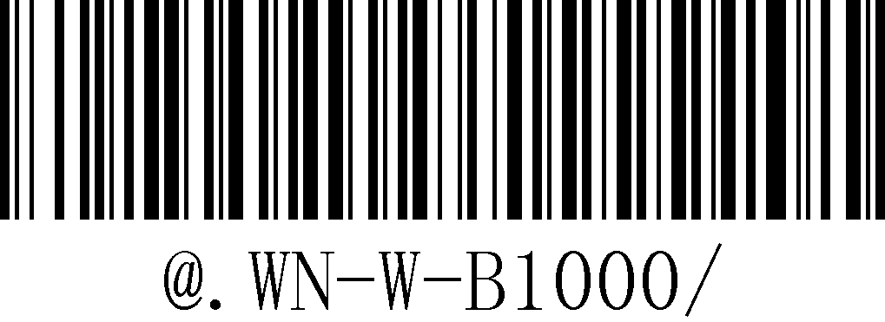
French | 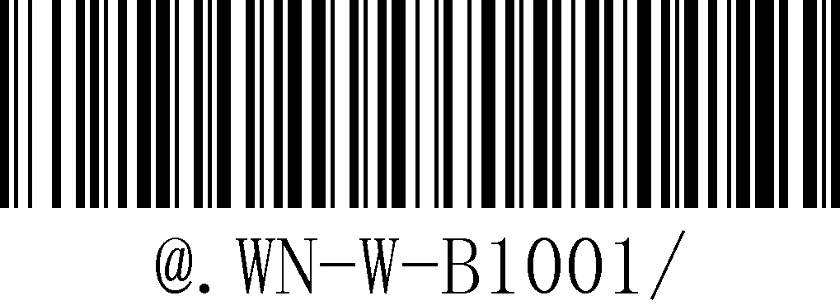
German | 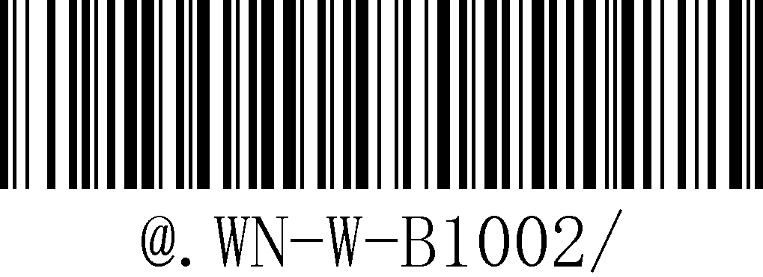
Turkish | 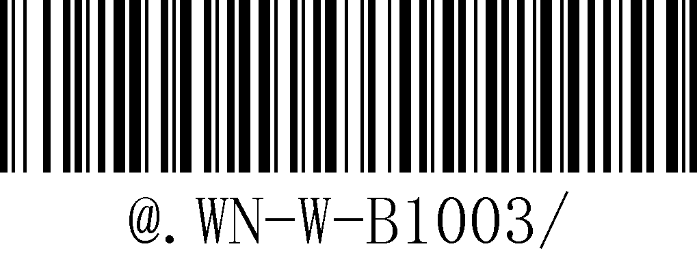
Belgium | 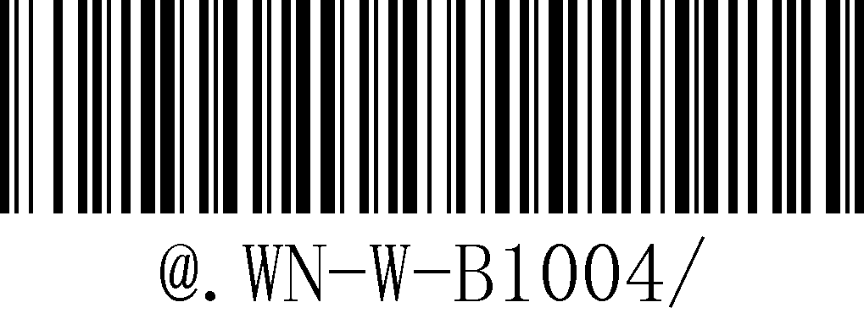
Brazil | 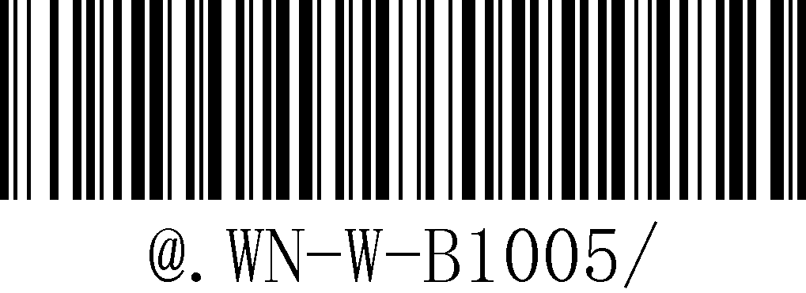
Crzch | 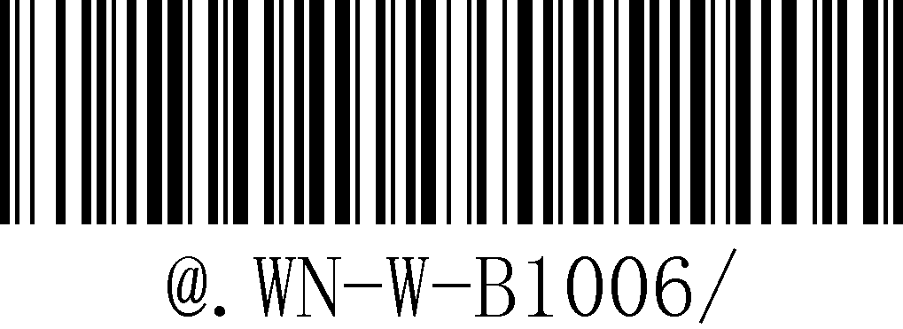
Spanish | 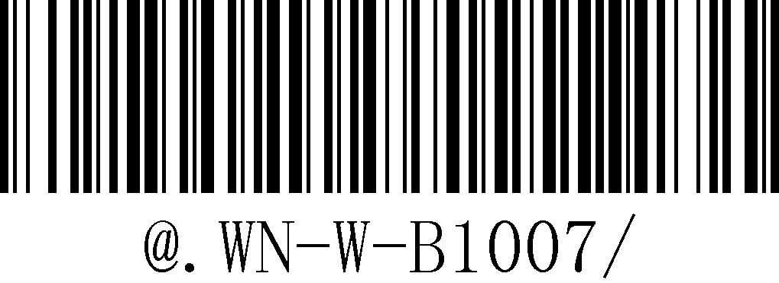
Italian | 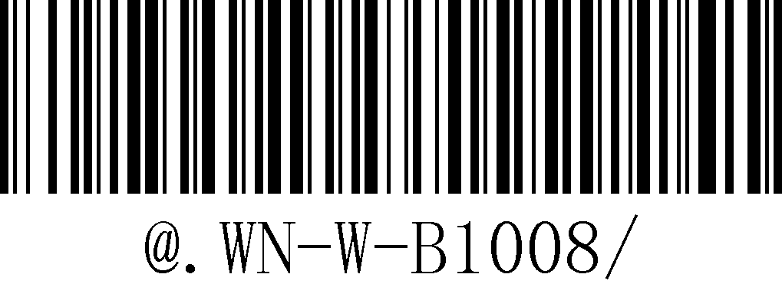
Note★:This setting code is valid for both the receiving end (Tx) and the transmitting end (Rx). If the multi-language is set when the wireless transmission is disconnected, the sending language setting will be successful and the receiving language will not be changed.

  - View Parameter
Funtion | Note
Output system parameter | - Battery Volume  - Firmware Version
Output battery volume | Battery volume "Full."、"Middle"、"Low."。

Output System Parameter | 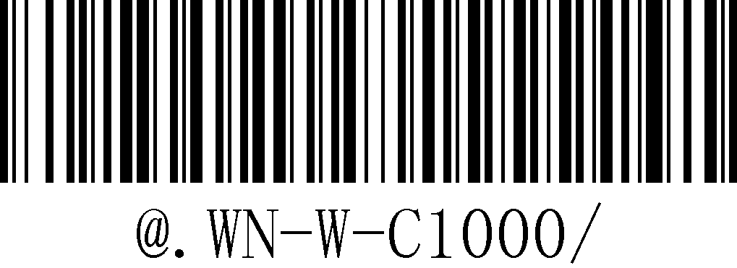
Output Battery Volume | 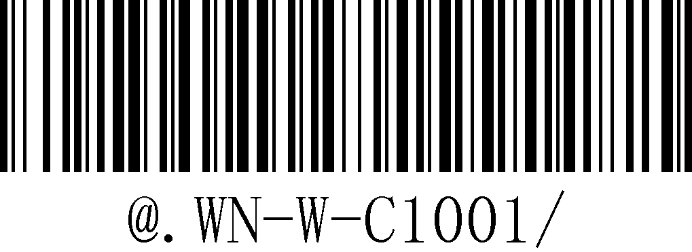

  - Working Mode
Function | Note
*Universal Mode | Scan and transmit, failure alarm
Cache Mode | When the data upload fails, it will be stored in the barcode scanner, and the data will not be uploaded until the wireless connection is stable.
Inventory Mode | After scanning the barcode, the data is directly stored in the barcode scanner. The data will not be deleted until [Clear Data] is scanned. During this period, you can scan [Upload Data] to send the data to the receiver or directly upload to the PC
Upload Data | Upload barcode data
Data Amount | The amount of upload barcode data
Clear data manually | After uploading data in inventory mode, manually scan the setup barcode to clear all barcode data in inventory area
Clear data automatically | After setup this function,the barcode scanner will automatacally clear all datas afteruploading data in inverntory mode.

    - Mode Switch
Universal Mode | 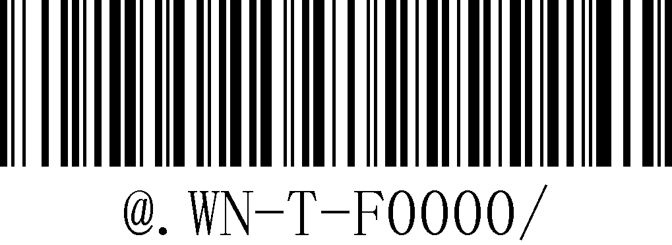
Cache Mode | 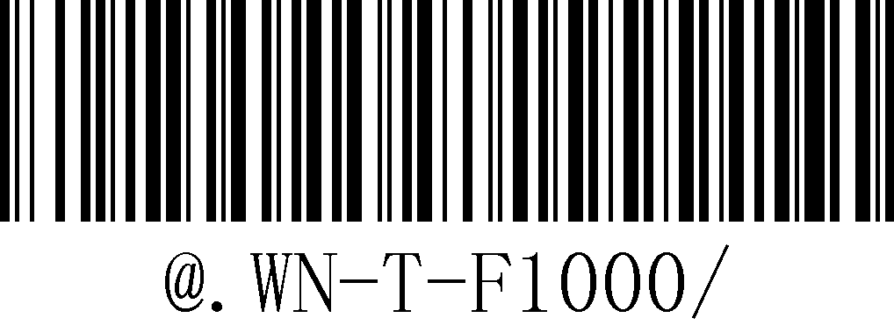
Inventory Mode | 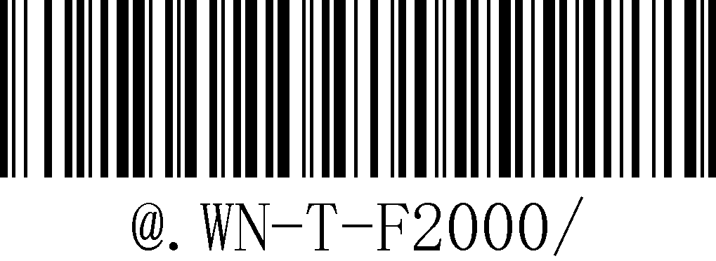

    - Setting Code in Inventory Mode
Upload data | 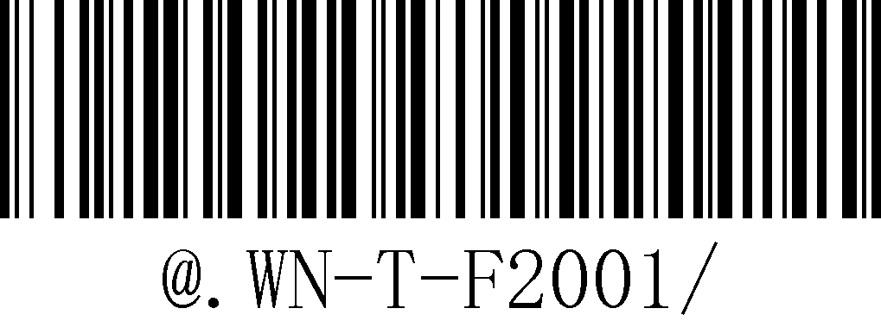
Data amount | 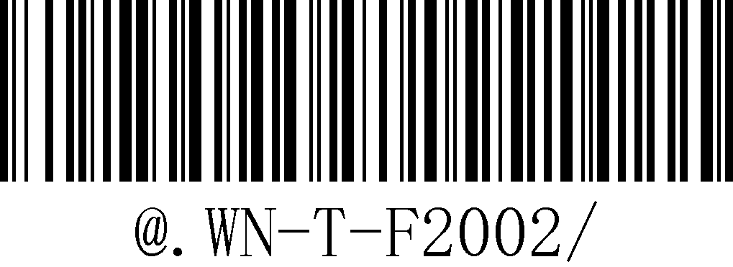
Clear data manually | 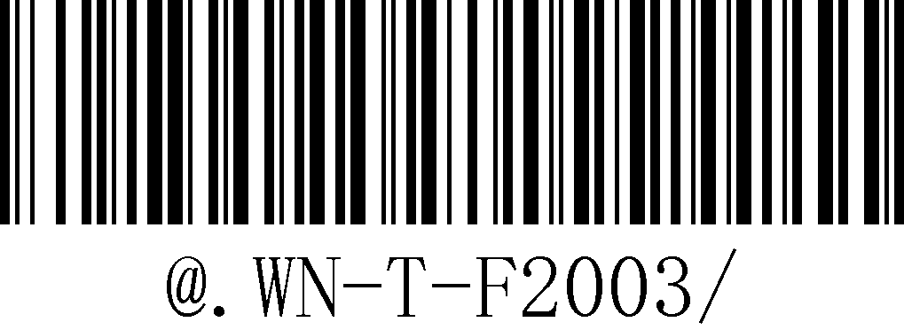
Clear data automatically | 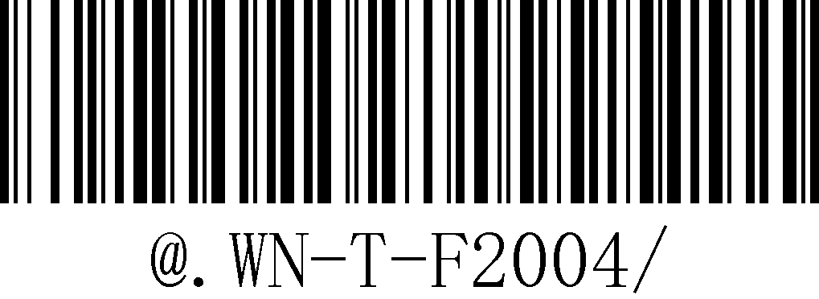

Description ☆:
Inventory Mode: Storage:49000pcs with 30 bytes data
Storage:104500pcs with 13 bytes data
Note★:1.When uploading inverntory data, please make sure the wireless connnection is stable to prevent data loss.
2.It will clean inventory data and cache data when swith to “clean data manually”.

  - Characters input/output/keyboard format setup
    - Case control and keypad switches
Function | Note
*CapsLK detection is on | Caps detection is enabled, keyboard Caps does not affect output  Example:Barcode content:123ABCdef  Turn on Caps Output: 123ABCdef  Turn off Caps Output:123ABCdef
CapsLK detection is off | Turn off Cap detection,keyboard Caps will lock and affect output  Example:Barcode Content:123ABCdef  Turn on Caps Output:123abcDEF  Turn off Caps Output:123ABCdef
Turn on Keypad output | You need to setup the output format as GBK format if turn on Keypad output.And need to setup the language as English if the current language is German.Other language no need setup.

CapsLK detection is on | 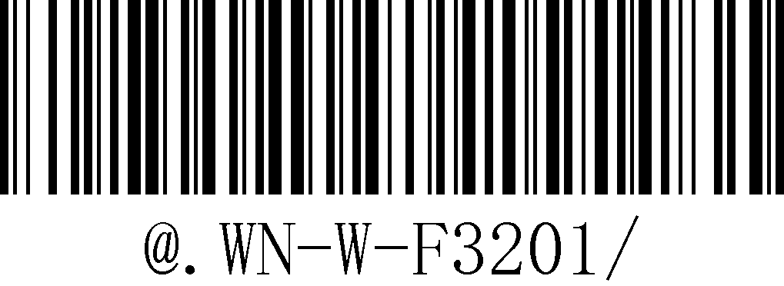
CapsLK detection is off | 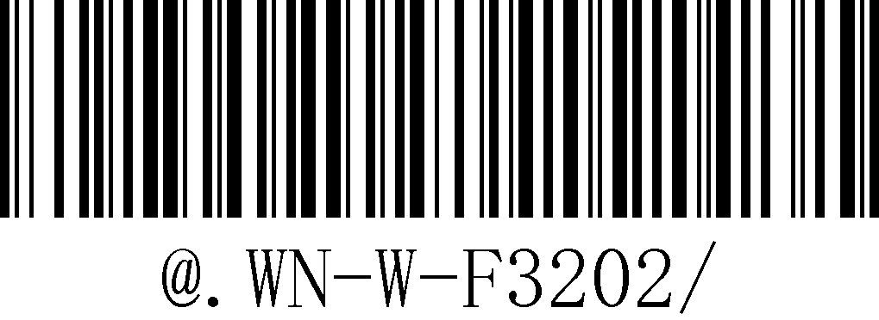
Turn of Keypad output | 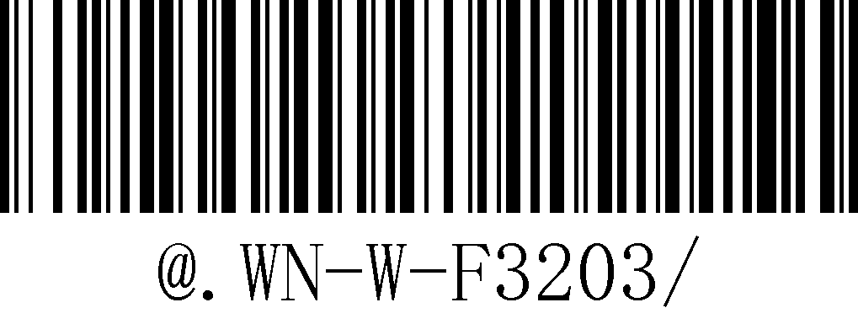

    - Output Format & Function Keys Setup
Funtion | Note
*GBK Output | 1.Support TXT & Excel output  2.Open TXT or Excel,scaning barcode and check if the data transmit.
Unicode Output | 1.Supprt Word output  2.Note:WDI2000 module need to setup to UTF-8 OUTPUT.
Function Keys Output | 1.Support test at Excel  2.Added function key suffix:  Example:Setting function key “→” as suffix.The cursor will point to the right cell after output data in Excel.

GBK Output | 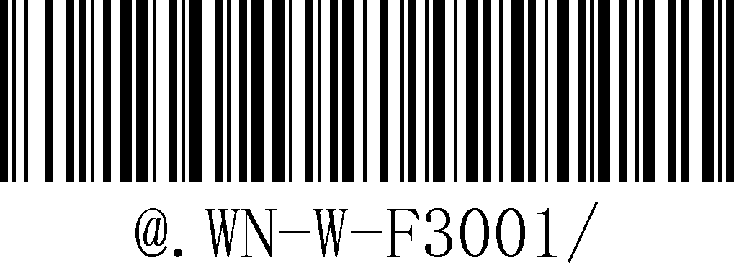
Unicode Output | 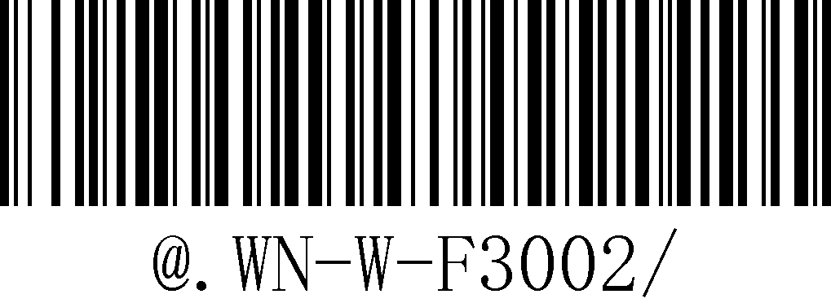
Function Keys Output | 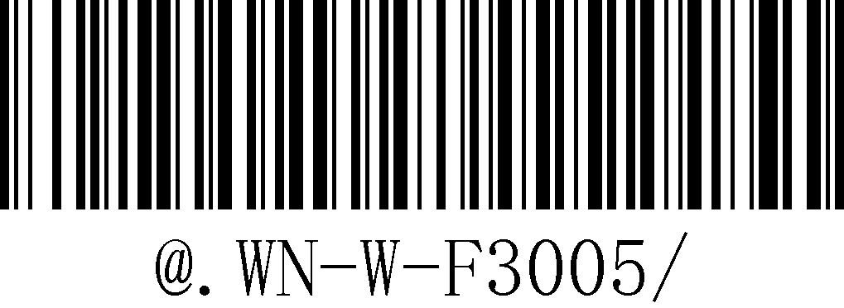

  - Sleep Time Setup
1 minute | 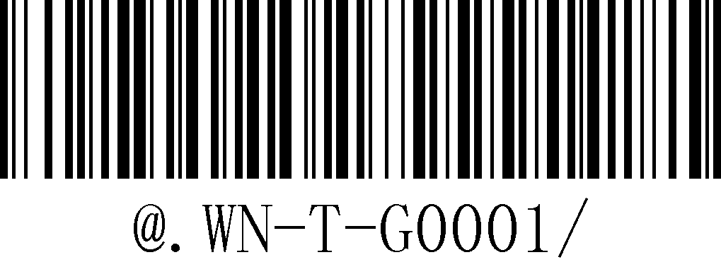
5 minutes | 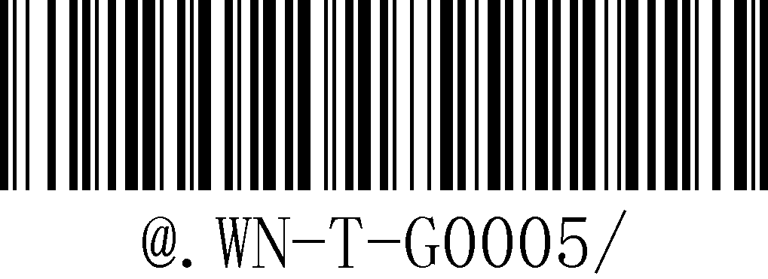
15 minutes | 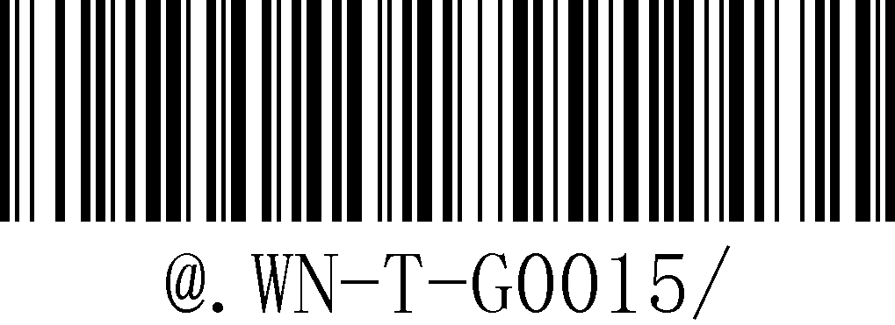
45 minutes | 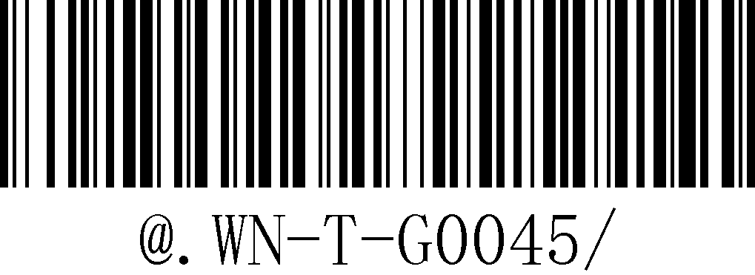
No Sleep | 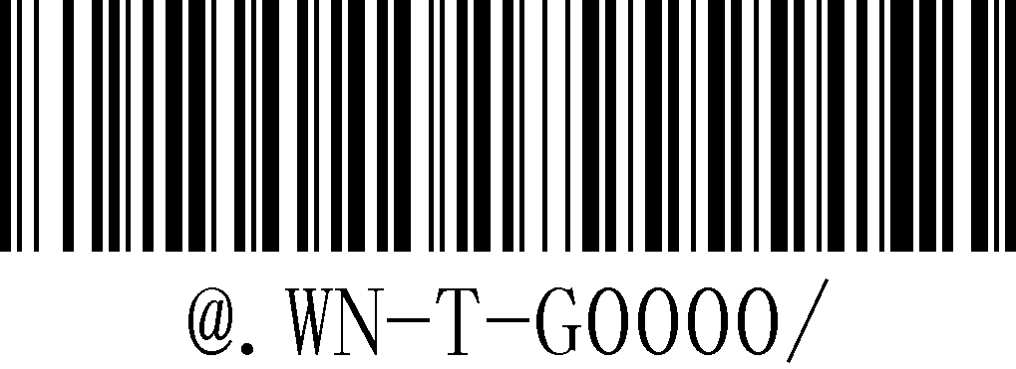
Immediately Sleep | 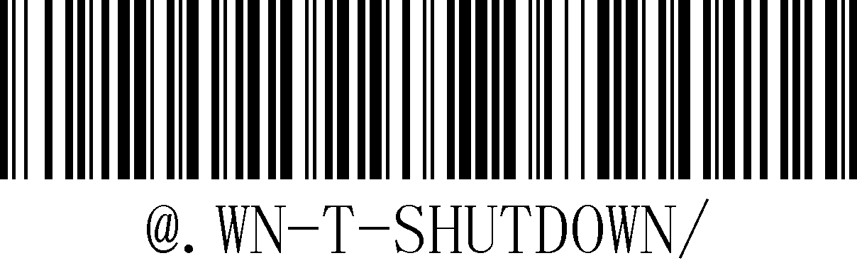

Description ☆: Sleep time calculation method:60 * x = n (s),x is the decimal value of the last 2 digits of the barcode

  - Restore Factory Default Setting
Function | Note
Restore Default Value | - autoSetFactory flag unchanged  - Data output mode unchanged  - Keyboard language unchanged  - Buzzer sounds unchanged  - Locked frequency flag unchanged

Restore default value | 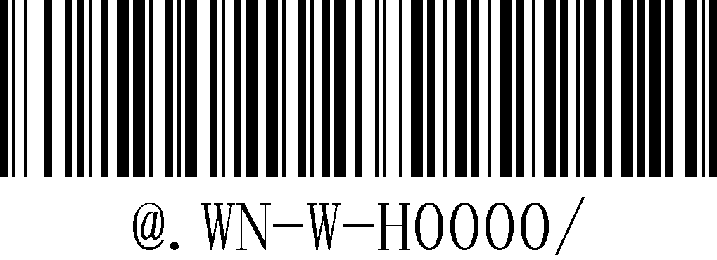

  - 0x0A Filter
Funtion | Note
Turn on 0x0A filter | The line feed 0x0A which in the middle of characters string will be filter after turn on this function
*Turn off 0x0A filter | If there is a line feedb in the middle of the data,tt will be output normally after turn off.

Turn on 0x0A fliter | 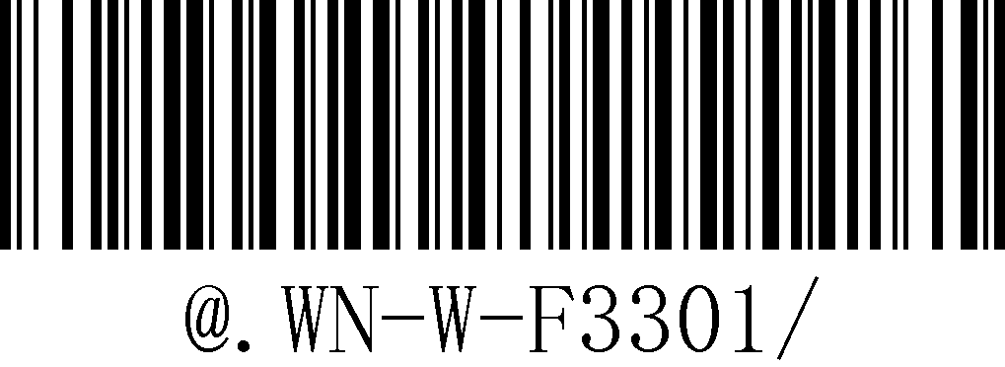
Turn off 0x0A fliter | 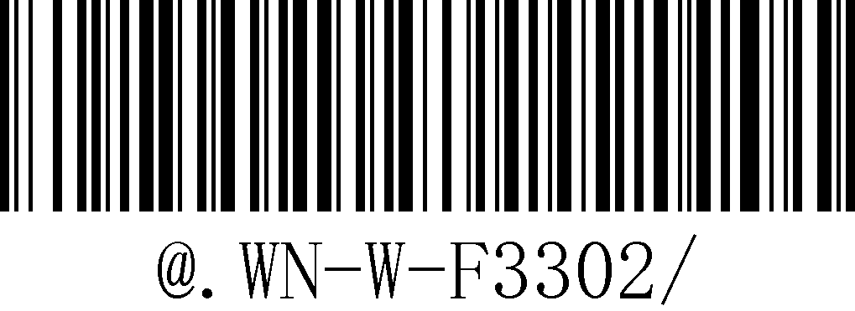

Description ☆: The line feed 0x0A which in the middle of characters string will be filter after turn on this function,the 0x0A will not be filter which in the end of the character string(the last 2 digits of the barcode).

  - Wired Output Mode

Function | Note
USB Output | USB-HID output
Virtual Serial Port Output | USB-VCP output  Note:The USB VCP needs to be installed with a USB-to-serial port driver for normal use; window10 does not need to install a driver.

USB output | 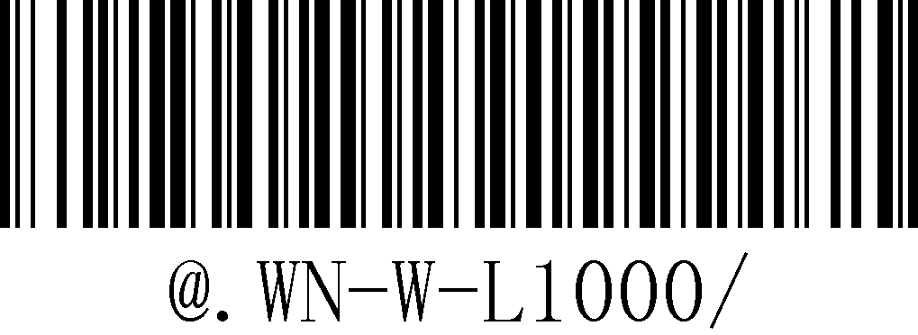
USB-VCP output | 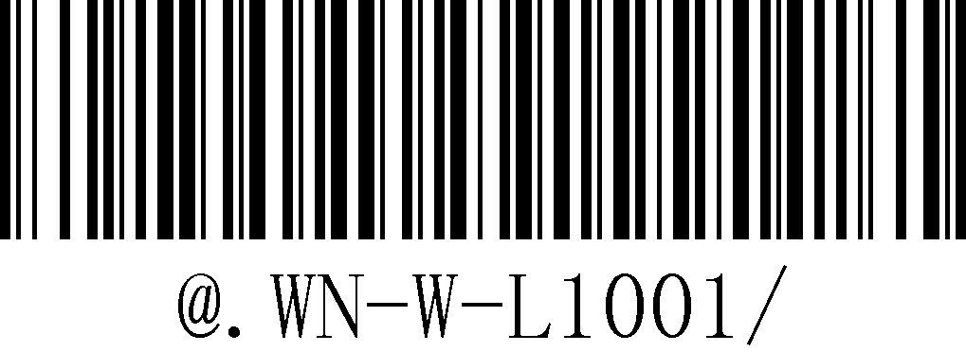

Note ★:
1.USB output & RS-232 output by default.System will choose USB output or RS-232 output automatically according to the hardware,no need setup.
2.You need to scan setup barcode when switching between USB ouput and Virtual Serial Port output.
3.If the dock data does not upload, please check whether the connection cable is used correctly, whether the USB device enumeration is normal, and whether it has entered the upgrade mode.

  - Sender End Wired Output Switch
Function | Note
Turn on the USB wired output | The transmitter is connected to the PCB via a USB cable, the data can be directly transmitted through USB without wireless transmission after turn on USB wired output.
*Turn off the USB wired output | The USB cable only use for charging and data only transmitted via wireless after turn off the USB wired output

Turn on the USB wired output | 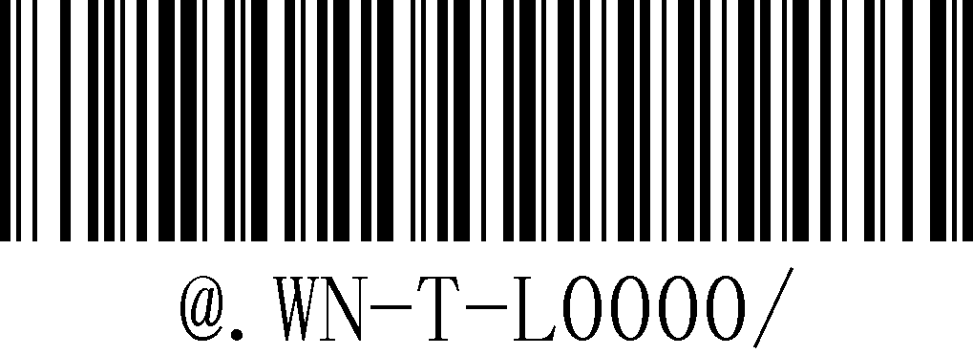
*Turn off the USB wired output | 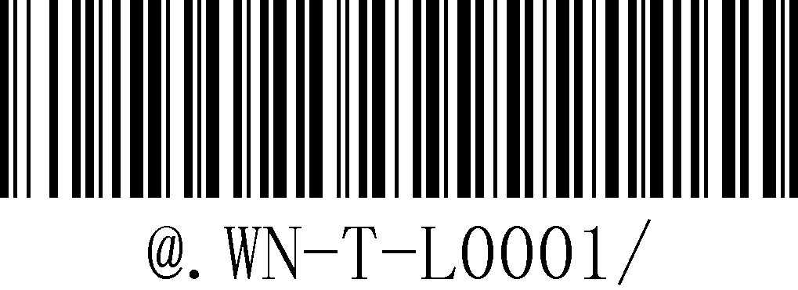

Note ☆:USB wired output switch only use for sender end

  - Serial Port Setup of Receiver End
    - Baud Rate Setting
2400 | 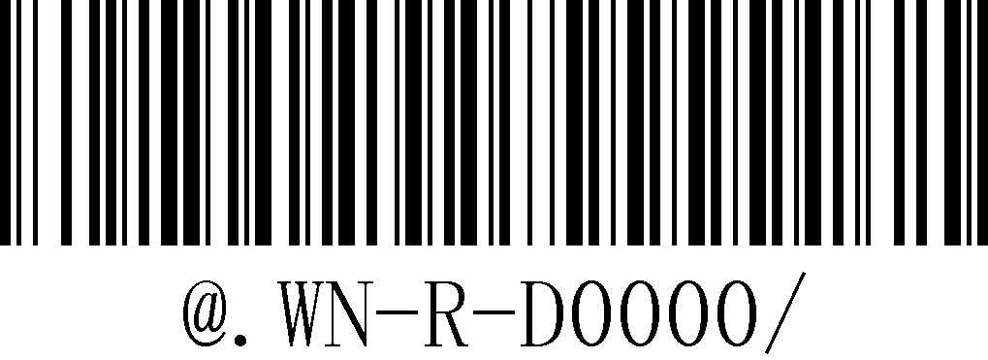
4800 | 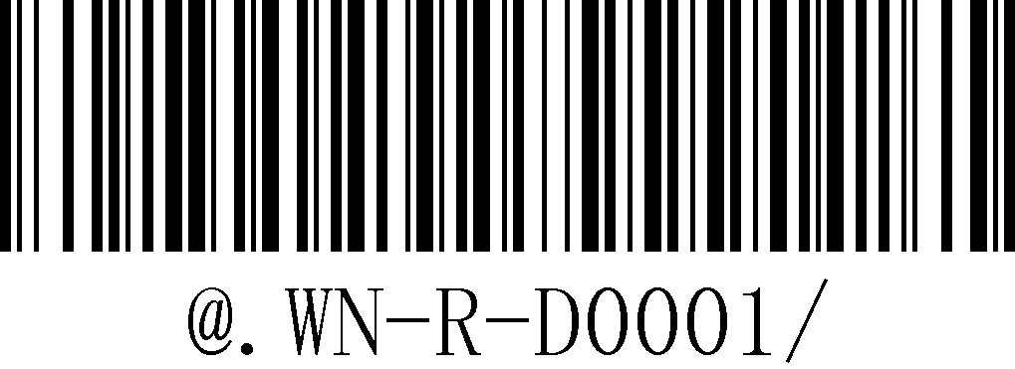
*9600 | 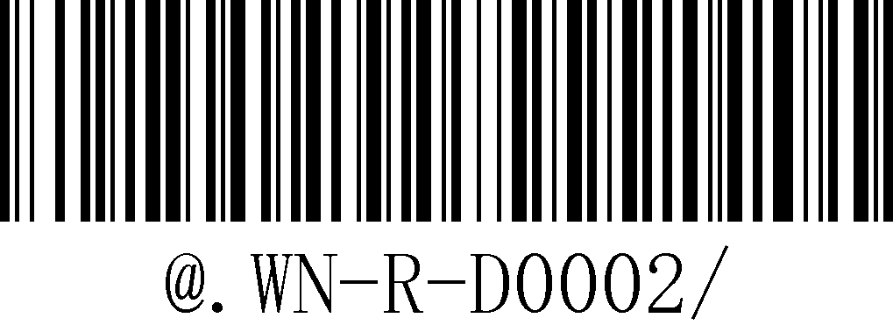
19200 | 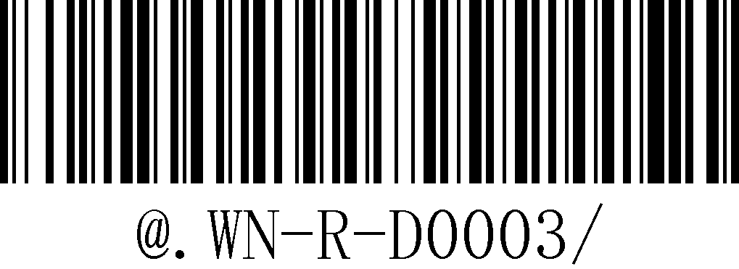
38400 | 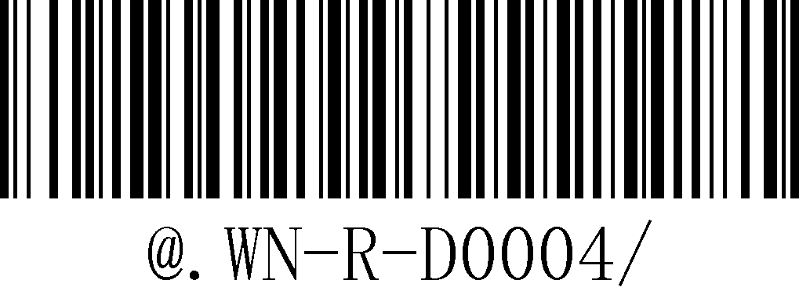
57600 | 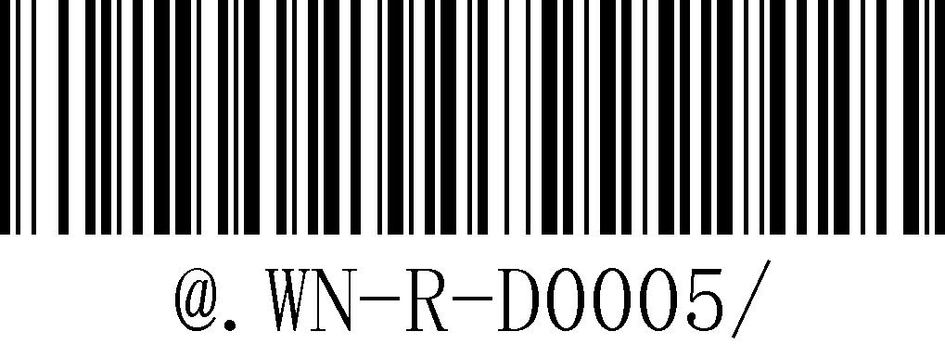
115200 | 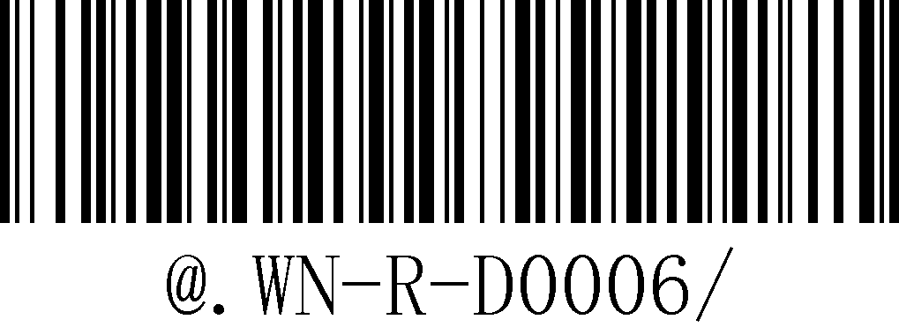

    - The Length of Data
7 data bits | 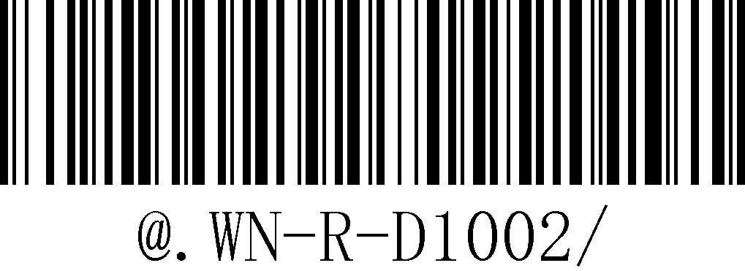
*8 data bits | 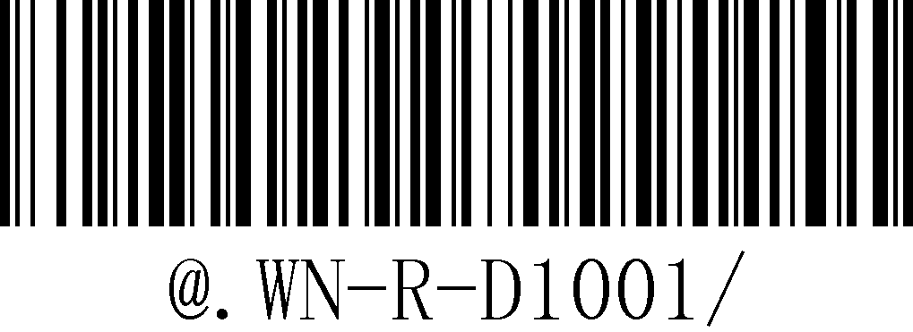

    - Stop Bit
*1 stop bit | 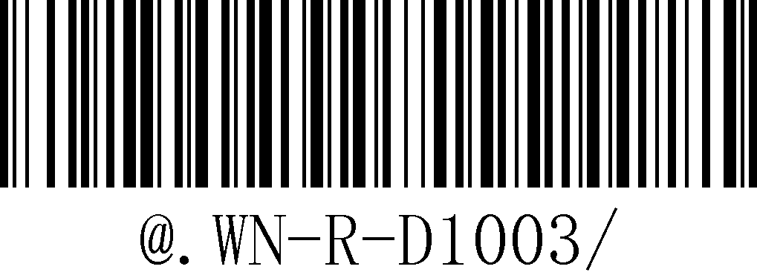
2 stop bits | 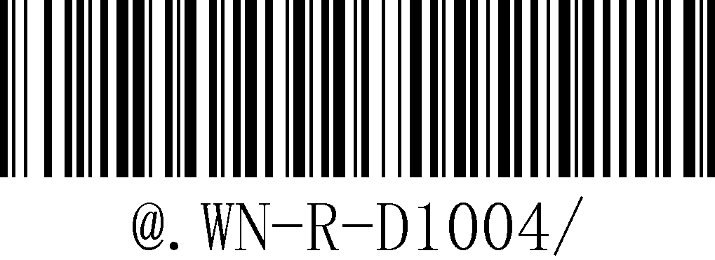

    - Parity Bit
*No Parity Bit | 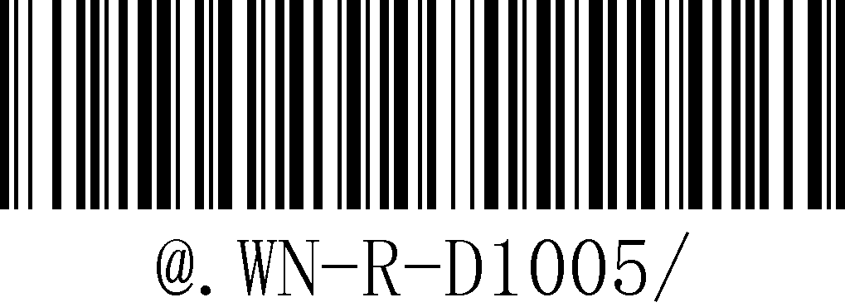
Odd Parity Bit | 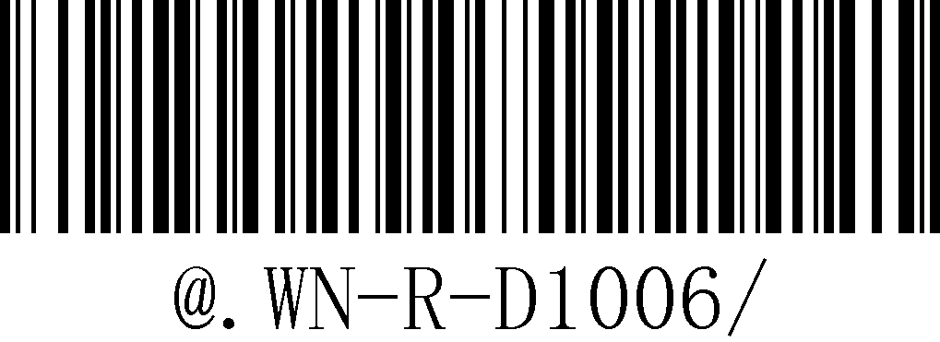
Even Parity Bit | 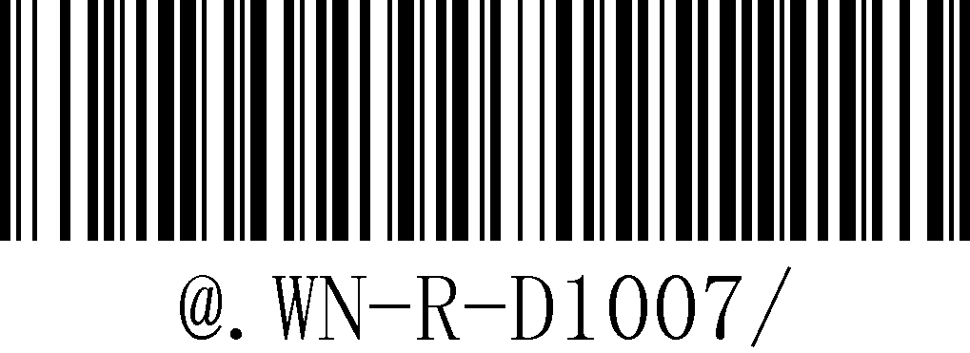

Note ★:Serial port setting only work at the device which supported serial port output.

  - Start Character Mode Setting
No Start Character | 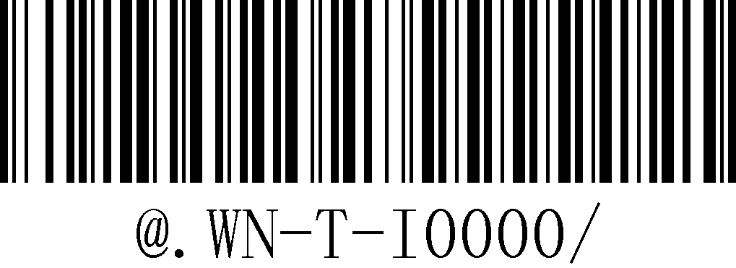
Customize Start Character+Barcode | 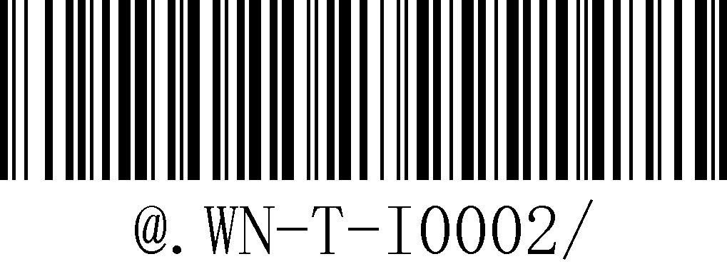
Save and exit | 

Example:Set the start symbol of the barcode “1234567” to “# Ab9”, that the content of the output barcode is “# Ab91234567”.
1.Starting up
2. Scan [custom start character]
3. Then scan the setting barcodes corresponding to [#], [A], [b], and [9] in this order.
4. Scan the [Save and Exit] barcode
5. The max length of start character is 10 digits.

  - Terminator Character Mode Setup
No Terminator Character | 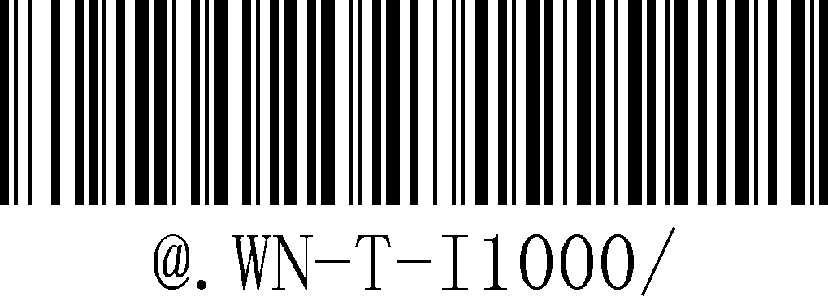
Customize Terminator Character | 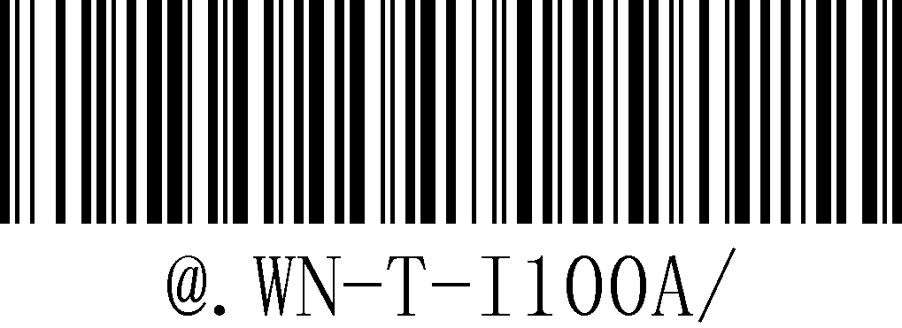
Save and exit

Example:Set the terminator symbol of the barcode “1234567” to “%B”, that the content of the output barcode is “1234567%B”.
1.Starting up
2. Scan [custom terminator character]
3. Then scan the setting barcodes corresponding to [%], [B].
4. Scan the [Save and Exit] barcode
5.Factory default terminator character is :0x0D(Enter)
6.The max length of terminator character is 10 digits.
7.Common terminator:0x0D(Enter)，0x0A(line feed)，0x09(Tab)

0x0D(Enter) | 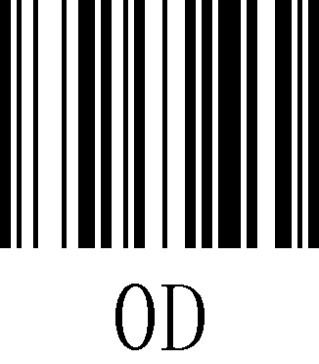
0x0A(line feed) | 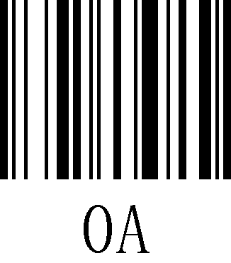
0x09(Tab) | 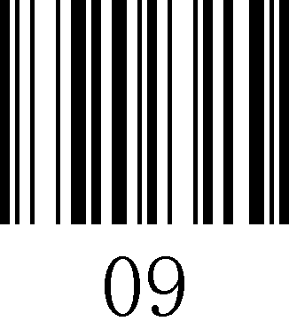

  - Barcode Scanner Prompt Tone Selection
Turn on Starting up sound | 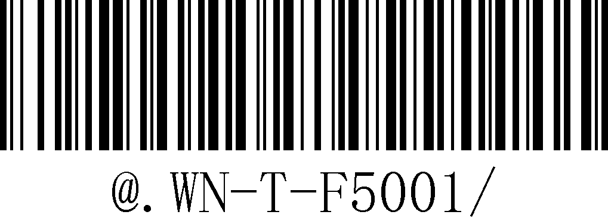
Turn off Starting up sound | 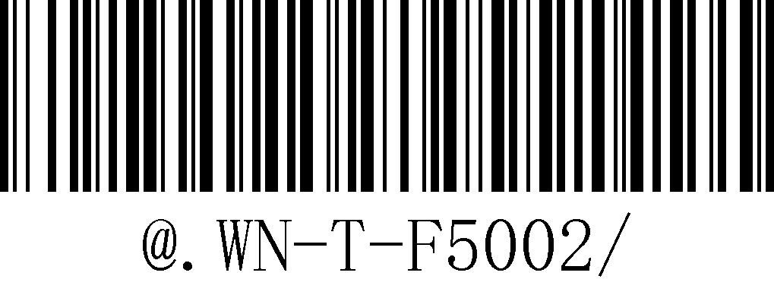
Turn on Transmittion sound | 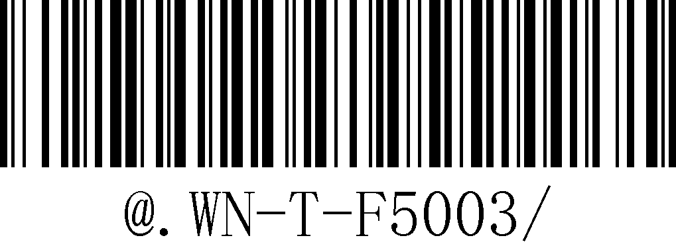
Turn off Transmittion sound | 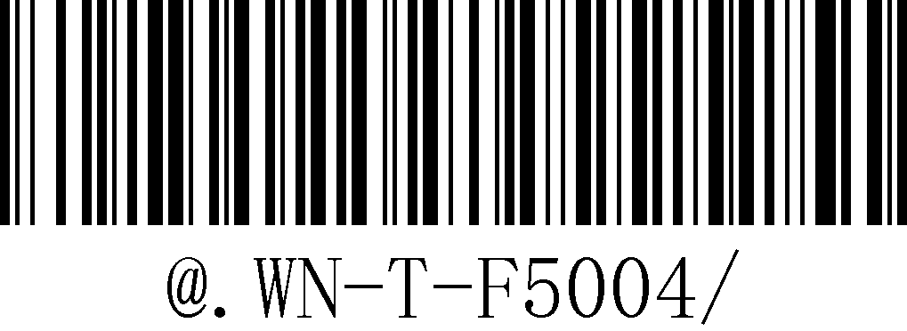

Description:This function is mainly used for the module. Most of the modules have their own startup sound and barcode scanning sound, so the startup sound of the PCB and the wireless transmission sound are turned on. The two sounds overlap. Therefore we added the settings for sound switch which respond to the noise and repeat sounds of the modules.

  - Prompt Tone Selection Of The Receiver Base
Turn on Starting up sound | 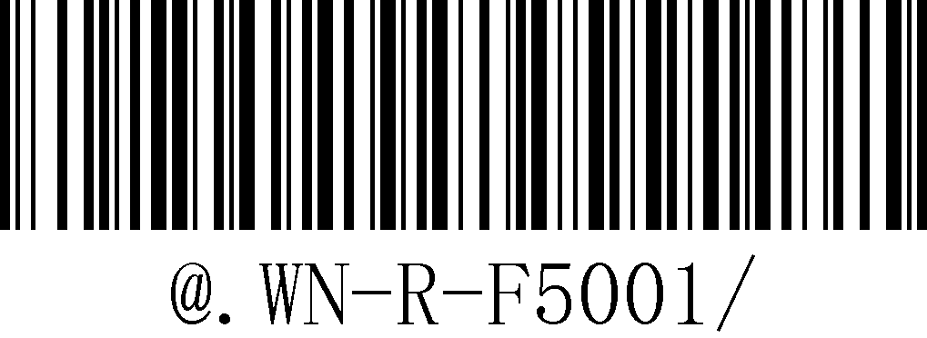
Turn off Starting up sound | 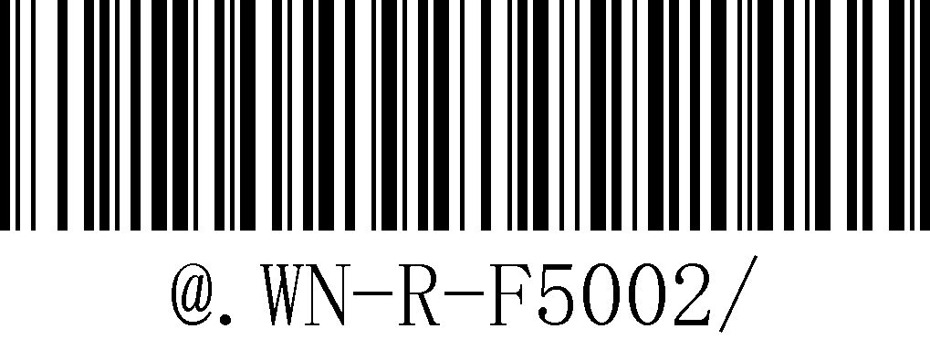
Turn on Transmittion sound | 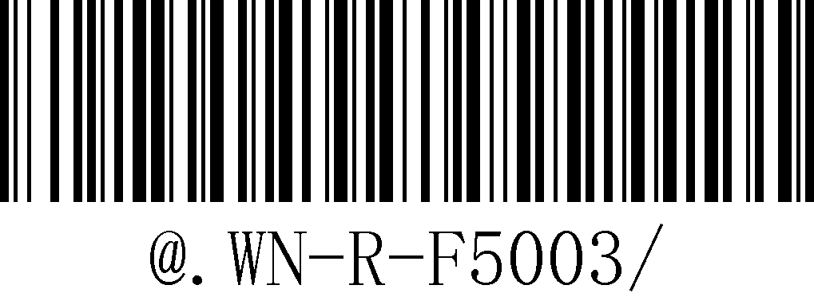
Turn off Transmittion sound | 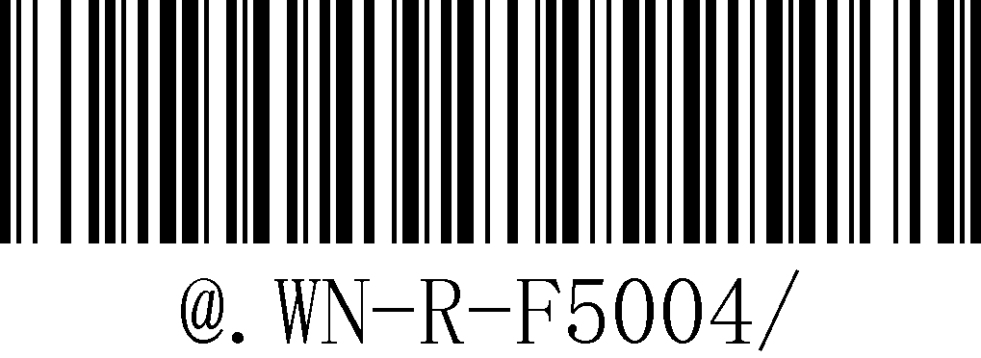

  - Barcode Scanner Vibration Alert Setting

Turn on Vibration | 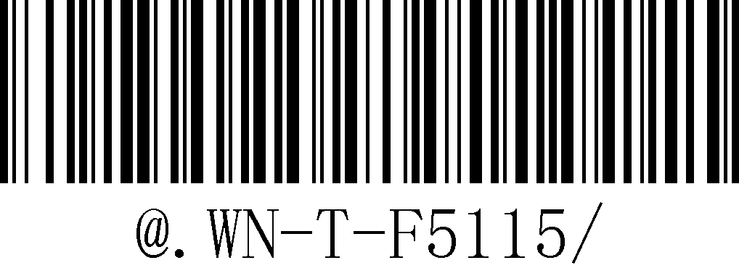
Turn off Vibration | 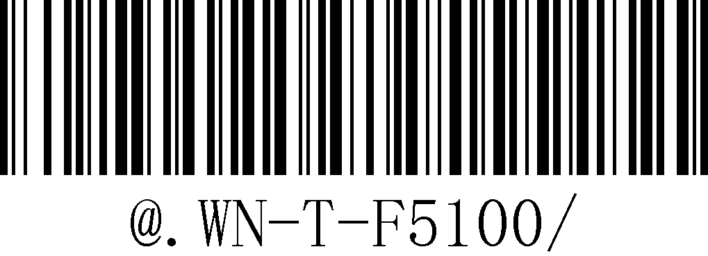

Description:It will trigger vibration when decoding sucessful.

- Part Command Setting
  - Buttons
    - Barcode Scanner Buttons Function
Funtion | Note
Startup | Short press the button at the power off state
Trigger Scan | Press the button at the power on state
IOS Keyboard Control | In the power-on state, long press the button for 3s to pop / hide the Apple phone keyboard.
Force Sleep | In the power-on state, press and hold the button for 10s to force the power off

    - Receiver Base Button Funtion
Funtion | Note
Connection State | In the power-on state, short press the button to switch the connection state(switch between the following two states).  - Disconnect from the receiver  - Waiting for connection
Output Version No. | In the power-on state,long press the button for 3s to output the version No. of thereceiver base.

- Sounds & Light Prompt Description
  - LED State Description
    - Barcode Scanner LED light
State | Description
Waiting for connection | The LED will flash every 600ms interval at waiting for connection state.(one flash include 1 light up and 1 light off)
Connected | The LED will keep lighting at connected state

    - Receiver Base LED light
State | Description
Connected | The LED will keep lighting at connected state
Waiting for connection | The LED will flash every 1s interval at waiting for connection state.(one flash include 1 light up and 1 light off)
Disconnect with receiver base | The LED will off light and flash every 5s interval at disconnect with the receiver base state(one flash include 1 light up and 1 light off).
Pairing | The LED will keep flash at pairing state.

Character Table
Control Character | Hexa
^@（NULL） | 00 | 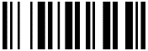
^A（SOH） | 01 | 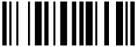
^B（STX） | 02 | 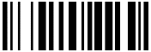
^C（ETX） | 03 | 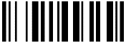
^D（EOT） | 04 | 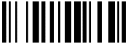
^E（ENQ） | 05 | 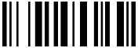
^F（ACK） | 06 | 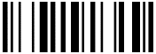
^G（BEL） | 07 | 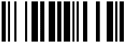
^H（BS） | 08 | 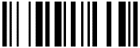
^I（HTab） | 09 | 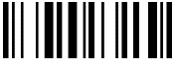
^J（LF） | 0A | 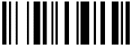
^K（VTab） | 0B | 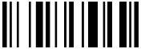
^L（FF） | 0C | 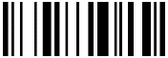
^M（CR） | 0D | 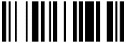
^N（SO） | 0E | 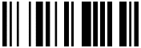
^O（SI） | 0F | 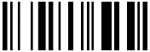
^P（DLE） | 10 | 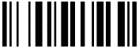
^Q（DC1） | 11 | 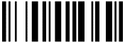
^R（DC2） | 12 | 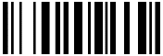
^S（DC3） | 13 | 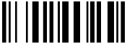
^T（DC4） | 14 | 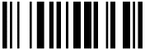
^U（NAK） | 15 | 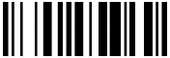
^V（SYN） | 16 | 
^W（ETB） | 17 | 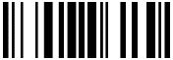
^X（CAN） | 18 | 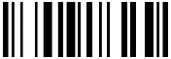
^Y（EM） | 19 | 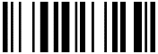
^Z（SUB） | 1A | 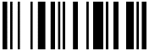
^[（ESC） | 1B | 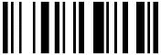
^\（FS） | 1C | 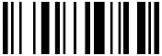
^]（GS） | 1D | 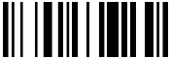
^^（RS） | 1E | 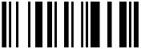
^_（US） | 1F | 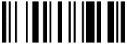
SPC | 20 | 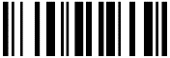
! | 21 | 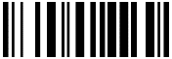
" | 22 | 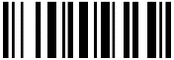
# | 23 | 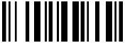
$ | 24 | 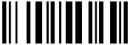
% | 25 | 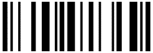
& | 26 | 
' | 27 | 
( | 28 | 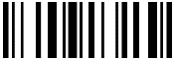
) | 29 | 
* | 2A | 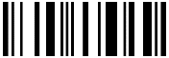
+ | 2B | 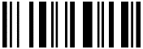
, | 2C | 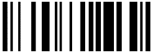
- | 2D | 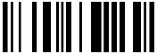
. | 2E | 
/ | 2F | 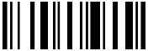
0 | 30 | 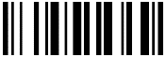
1 | 31 | 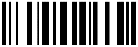
2 | 32 | 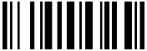
3 | 33 | 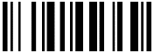
4 | 34 | 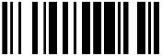
5 | 35 | 
6 | 36 | 
7 | 37 | 
8 | 38 | 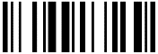
9 | 39 | 
: | 3A | 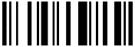
; | 3B | 
< | 3C | 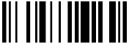
= | 3D | 
> | 3E | 
? | 3F | 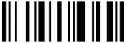
@ | 40 | 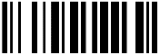
A | 41 | 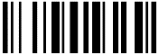
B | 42 | 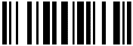
C | 43 | 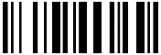
D | 44 | 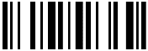
E | 45 | 
F | 46 | 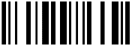
G | 47 | 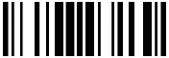
H | 48 | 
I | 49 | 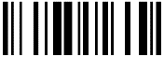
J | 4A | 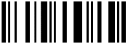
K | 4B | 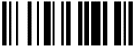
L | 4C | 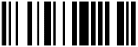
M | 4D | 
N | 4E | 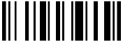
O | 4F | 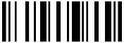
P | 50 | 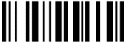
Q | 51 | 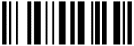
R | 52 | 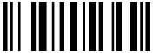
S | 53 | 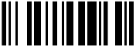
T | 54 | 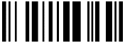
U | 55 | 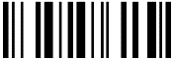
V | 56 | 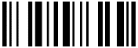
W | 57 | 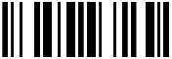
X | 58 | 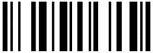
Y | 59 | 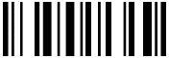
Z | 5A | 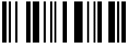
[ | 5B | 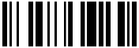
\ | 5C | 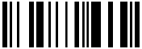
] | 5D | 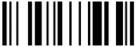
^ | 5E | 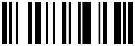
_ | 5F | 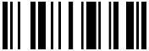
` | 60 | 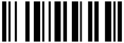
a | 61 | 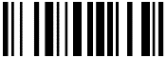
b | 62 | 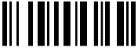
c | 63 | 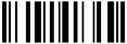
d | 64 | 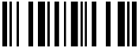
e | 65 | 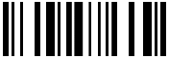
f | 66 | 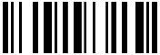
g | 67 | 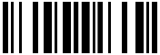
h | 68 | 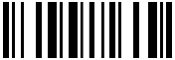
i | 69 | 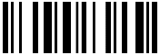
j | 6A | 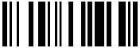
k | 6B | 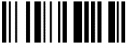
l | 6C | 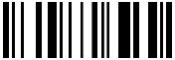
m | 6D | 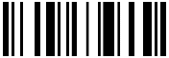
n | 6E | 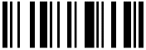
o | 6F | 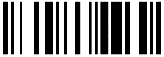
p | 70 | 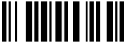
q | 71 | 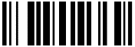
r | 72 | 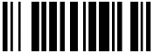
s | 73 | 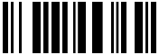
t | 74 | 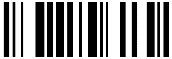
u | 75 | 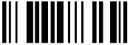
v | 76 | 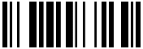
w | 77 | 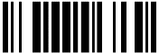
x | 78 | 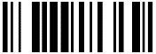
Y | 79 | 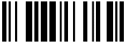
z | 7A | 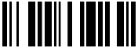
{ | 7B | 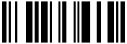
| | 7C | 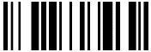
} | 7D | 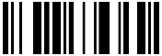
~ | 7E | 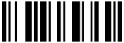
DEL | 7F | 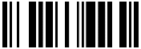
Function Key | Hexa
F1 | 80 | 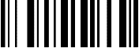
F2 | 81 | 
F3 | 82 | 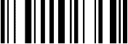
F4 | 83 | 
F5 | 84 | 
F6 | 85 | 
F7 | 86 | 
F8 | 87 | 
F9 | 88 | 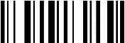
F10 | 89 | 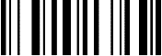
F11 | 8A | 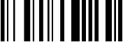
F12 | 8B | 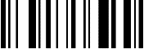
Backspace | 8C | 
Tab | 8D | 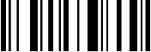
Return（ENTER） | 8E | 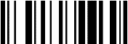
Enter（Numeric Keypad） | 8F | 
Esc | 90 | 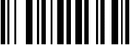
Arrow Down | 91 | 
Arrow up | 92 | 
Arrow right | 93 | 
Arrow left | 94 | 
Insert | 95 | 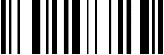
Home | 96 | 
End | 97 | 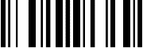
Page up | 98 | 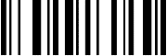
Page down | 99 | 
Left Shift | 9A | 
Left Ctrl | 9B | 
Left Alt | 9C | 
Left GUI | 9D | 
Right Shift | 9E | 
Right Ctrl | 9F | 
Right Alt | A0 | 
Right GUI | A1 | 
Caps Lock | A2 | 

